Connor Smith

8/20/2023

CIT - 95

Mohle

Giraffe Academy Assignment

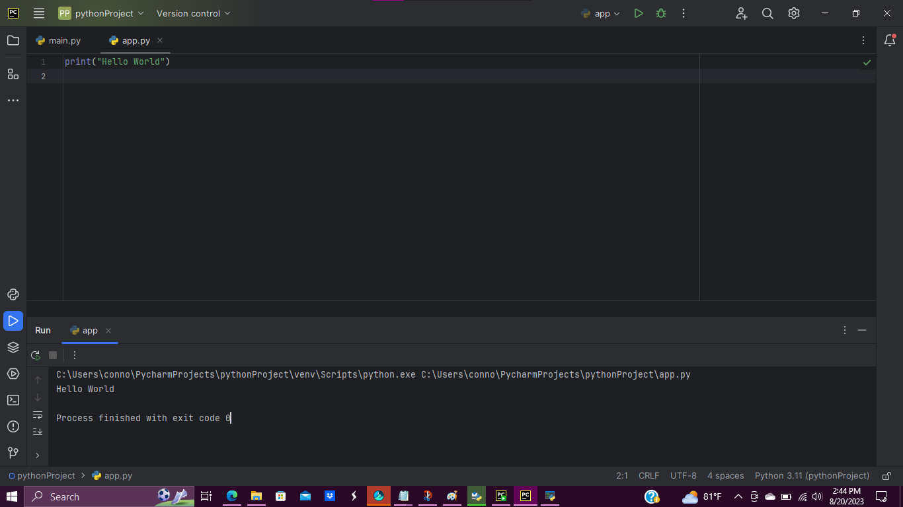

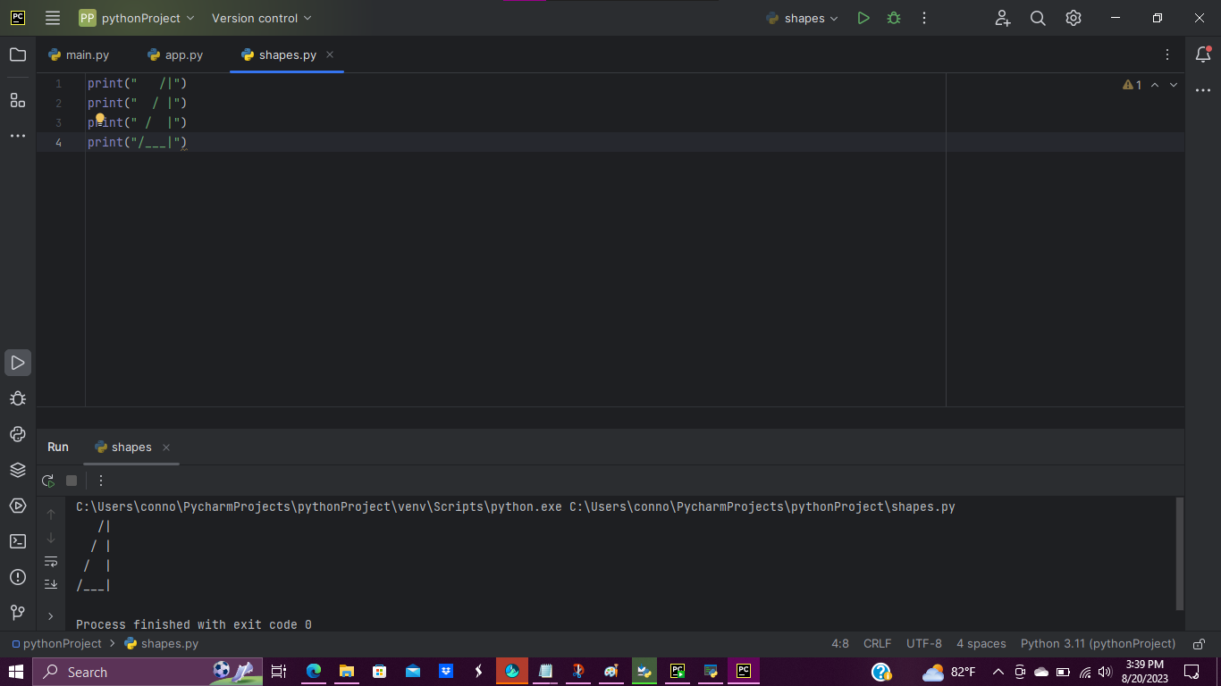

I had some challenges while coding the programs above. I initially thought the ‘Hello World’ program to be simple, despite too many steps at one time. I also thought the ‘Shapes’ program to be even better, despite trial and run errors with PyCharm. I only wish for the video to be shorter as I enjoyed the task.